**Spreadsheet**

**Class Six**

**Lab 24**

|  |
| --- |
| Lab Objectives:  * Addition * subtraction |

Let you are Ahnaf. You have made a list of your Bangla, English and Math exam results. You want to see your total marks

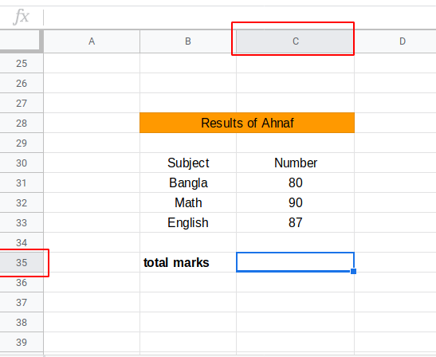

You will show your total mark in C35 position.

You need to add (80+90+87) which is in the position of C31+C32+C33 .

If you think vertically you need to add the number from C31 to C33

In sheets if you write C31:C33 it denotes you want to do something from C31 to C33

There are some basic formula for calculating your data .Like SUM,MINUS, MAX, MIN, AVERAGE, COUNT

Etc

# Addition

Use SUM formula to add anything. You have to use “=” just before the function name every time you want to write the function and also you have to use bracket after the name of a function.

To write SUM you have to write

=SUM()

Inside the bracket you have to mention the row and column position which number you want to add

For adding (80+90+87) you need to mention the position of 80 (C31), the position of 90 (C32) and the position of 87(C33) inside the SUM function.

So it will be look like this

**= SUM(C31:C32)**

write this and press enter to see the result

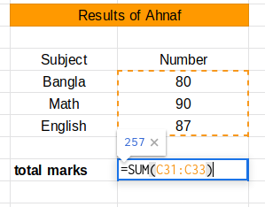

Result will be appeared

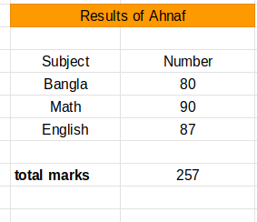

## ফেব্রুয়ারী 17 _16Every time you change the value of C31 to C33 the total marks will be changed automatically.

# Subtraction

Procedures are same as SUM function just use MINUS function instead of SUM.

Consider your result with Ramisa

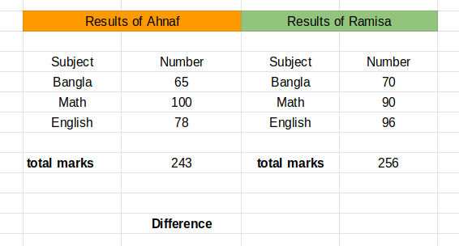

You need to calculate the difference between you and Ramisa. So subtract 243 from 256.

Find the position of 256 and 243

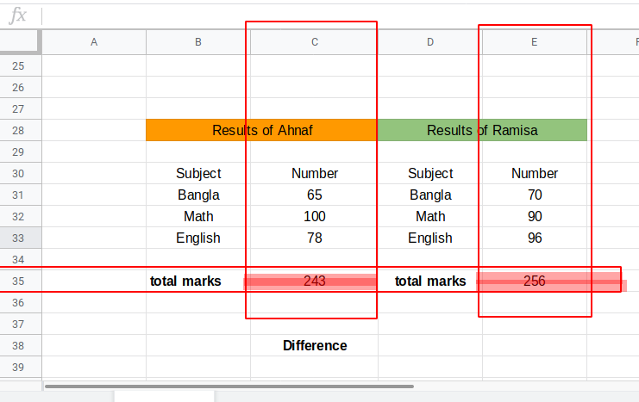

Position of 256 is E35 and C35 for 243.

Formula will be

=MINUS(E35, C35)

Notice, we have used “,” instead of “:” inside the function or subtraction

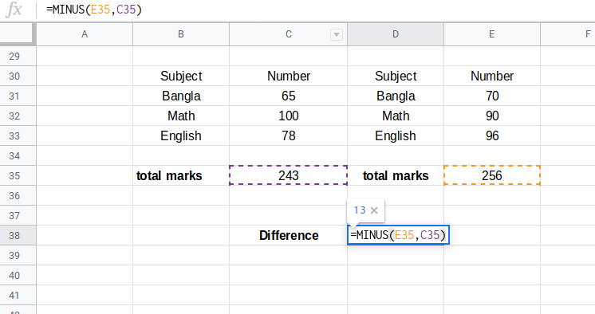

Here we go

